TO ALL CANMORE COLLEGIATE PARENTS AND GUARDIANS:
On behalf of our school, we would like to share with you the following information about student resources that are available from Castle Rock Research. CANMORE COLLEGIATE, we have been privileged to work with this Alberta-based company to access quality materials to support students, teachers, and parents.
To order print or digital products please visit:
https://schoolorders.solaro.com/5243

To help reduce shipping charges, orders will be individually packaged, aggregated and shipped to the school for pick up by each student. Orders can be placed between February 11, 2022 and February 20, 2022 with shipment following within a week after the closing date. For SOLARO digital orders, clients will receive an emailed confirmation for immediate activation.

The following resources are available with educational discounts:
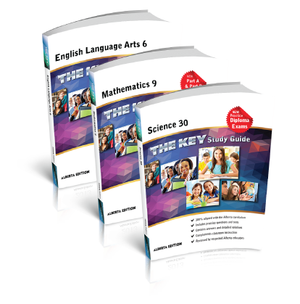
- The KEY Study Guides - Mathematics, English Language Arts, Science, and Social Studies courses across grades 3 to 12. Grade 12 Math and Science KEYs have been updated to include questions from recently released Diploma exams. $20.00 per copy
- Student Notes and Problems (SNAP) Workbooks – Instructional content, practice exercises, and unit assessments covering the breadth and depth of select Science and Mathematics courses. $20.00 per copy
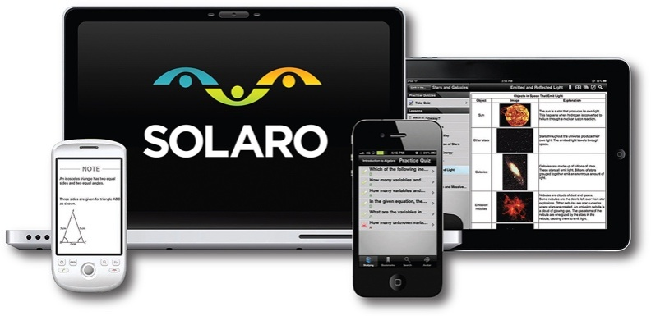
- Problem Solved – All of the questions from the respective SNAP books are presented along with the detailed solutions. Class Notes – An excerpt of each SNAP workbook that focuses students on the explanatory notes for each topic. $11.00 per copy
- SOLARO - $20.00 for an annual student license
  - access up to 10 courses across all available
grades and subjects, for 1 year
  - use online or on mobile devices,
  - more courses than are available in print,
  - learn more at View SOLARO Video.

Thank you,
CANMORE COLLEGIATE

