CCHS PowerSchoolClass Registration

The following instructions and screen shots are provided to help guide students and parents through the step-by-step process for requesting courses for the 2022-2023 school year. If you have any questions regarding the process, please contact the School.

To begin, go to https://powerschool.crps.ca/public/

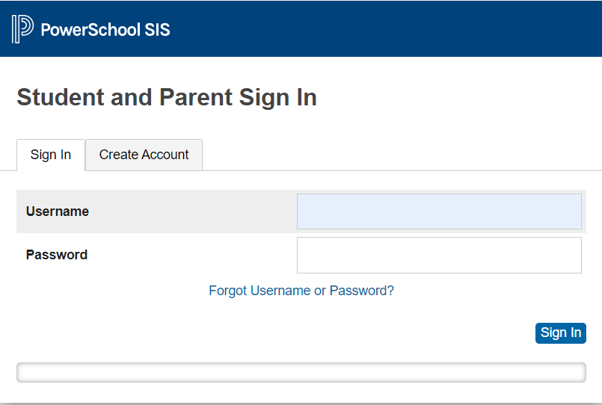

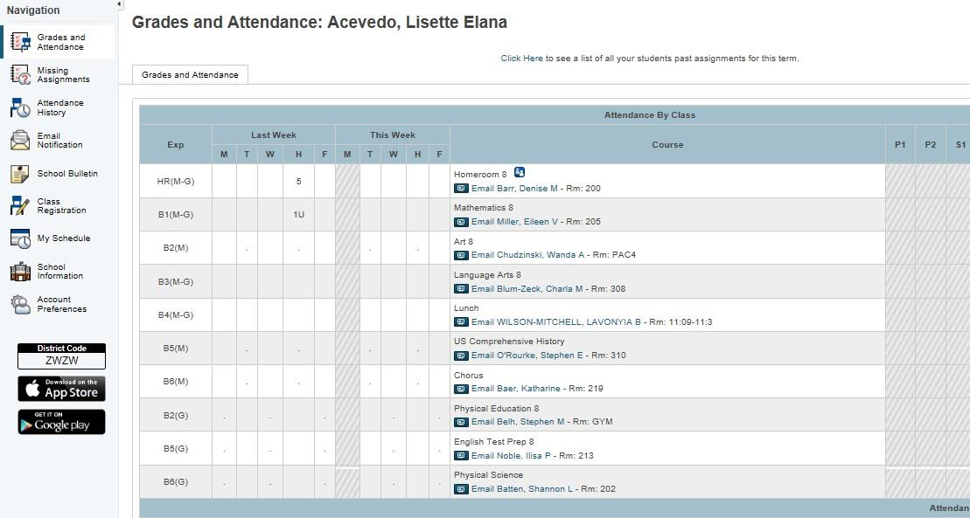
After entering your Username and Password, you will be directed to the Home Screen (example shown below). From this screen, select the Class Registration link on the left-hand side.

The Class Registration page provides information for each Course Category. Within each Course Category students are required to make a course request.

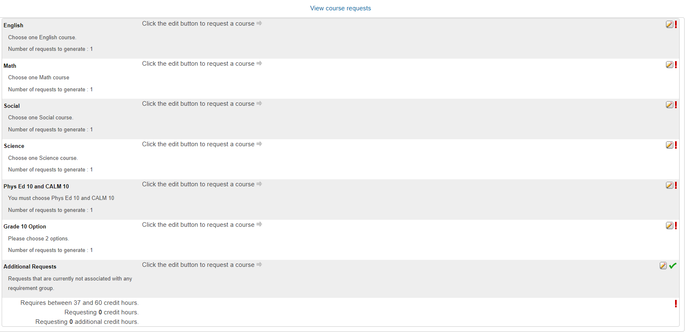
Students will need to click on each icon to view the options and decide which
course the student would like to request.
⃪

After selecting the icon, students / parents will see the following course options screen which provides Course Names, Numbers, Credits, etc.

Using the sample screen below the student has been recommended to take Humanities 10-1

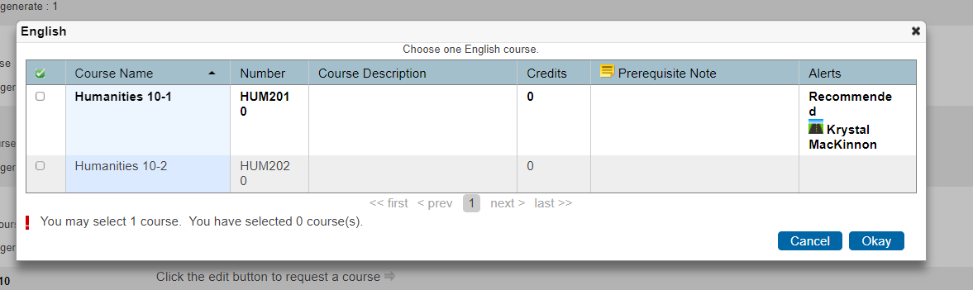

Please be sure to click on the icon located next to EACH CLASS and click Okay after you have chosen your course.

After selecting a course request within each category,
which will be reflected on the right-hand side,
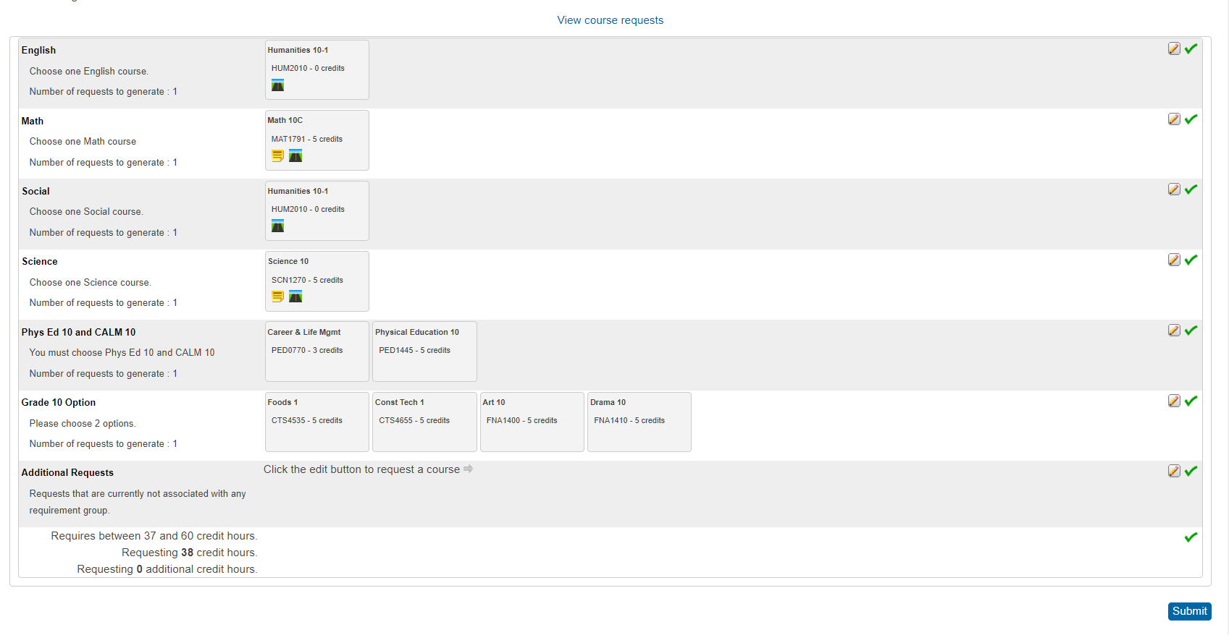
you can click ‘Submit’ to save.
⃪

PLEASE NOTE THE FOLLOWING:
• If you do not select enough credits, the system will not allow you to “Submit” the request.
• Students/parents will view the Course Requests screen by clicking on the words “View Course Requests”.
• Course selections you see are NOT in any particular order (in terms of the class period of the day) and the teacher assignments will not be confirmed until just prior to the start of school.

